Pizza Sales Analysis
1. Project Overview
This project analyzes pizza sales data to understand business performance and customer ordering behavior. The goal is to uncover insights into revenue trends, product performance, and order patterns to support data-driven decision-making and optimize sales strategies.
2. Dataset Summary
- Rows: 46621 rows
- Columns: 12
- KeyFeatures:pizza_id,order_id,pizza_name_id,quantity,order_date,order_time,unit_price,total_price,pizza_size,pizza_category,pizza_ingredients,pizza_name
- Missing Data: None
3. Exploratory Data Analysis using Python
We performed data preparation and cleaning using Python:
- Data Loading: Imported dataset using pandas
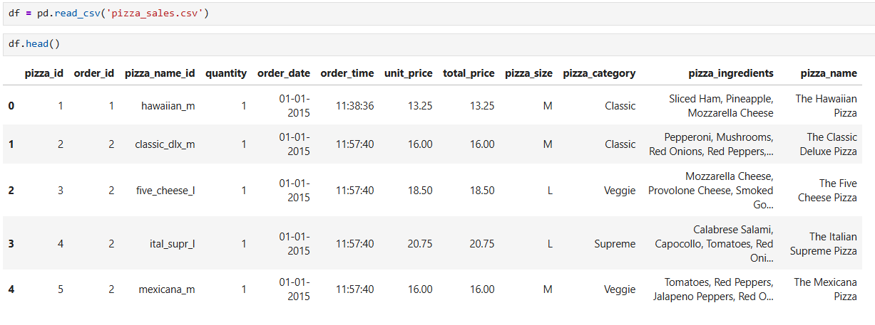
- Initial Exploration: Used .info() and .describe() to understand structure and statistics
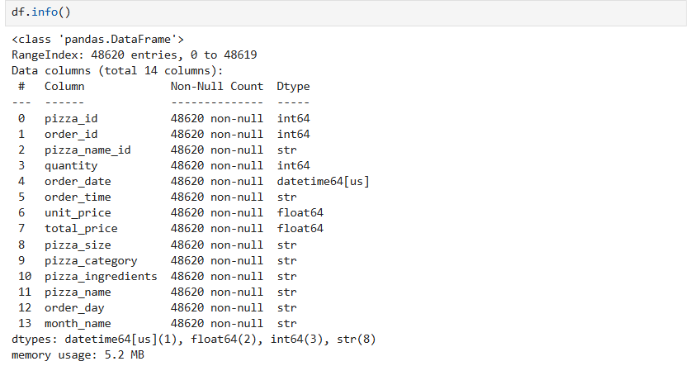
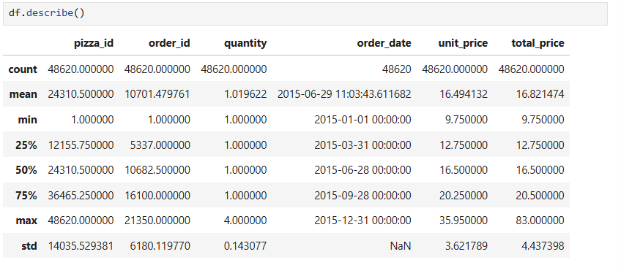
- Data Cleaning: Checked for missing values and ensured correct data types
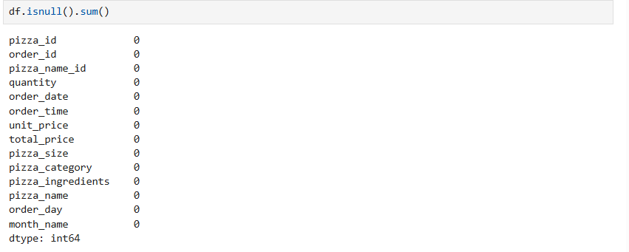
- Feature Engineering:
Extracted month, day of week, from order_date and order_time
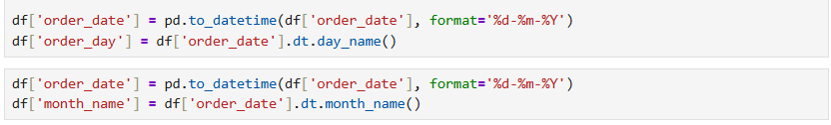
- Database Integration: Loaded cleaned data into MySQL for SQL analysis
4. Data Analysis using SQL (Business Transactions)
We used SQL to extract key business insights:
-Key Performance Metrics
- Total Revenue: Calculated the overall revenue generated from all pizza sales.
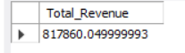
- Average Order Value (AOV): Measured the average amount spent per order.
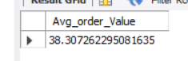
- Total Pizzas Sold: Computed the total number of pizzas sold.
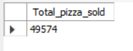
- Total Orders: Counted the number of unique orders.
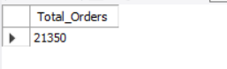
- Average Pizzas per Order: Evaluated the average quantity of pizzas per transaction.
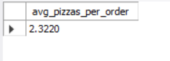
- Sales Trends Analysis
- Daily Trend for Orders: Analyzed how order volume varies across different days of the week.
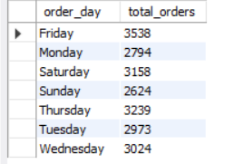
- Monthly Trend for Orders: Evaluated order patterns across months to identify seasonality.
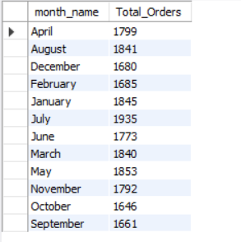
- Revenue Distribution
- Sales by Pizza Category (%): Determined the revenue contribution of each pizza category.
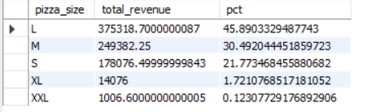
- Sales by Pizza Size (%): Measured how different pizza sizes contribute to total revenue.
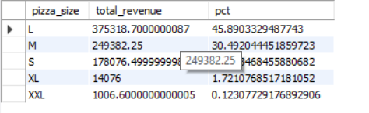
- Product Performance Analysis
- Top 5 Pizzas by Revenue: Highlighted the highest revenue-generating pizzas.
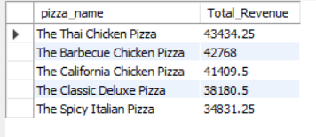
- Bottom 5 Pizzas by Revenue: Identified underperforming products.
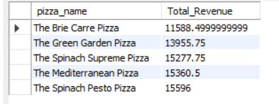
- Quantity-Based Analysis
- Top 5 Pizzas by Quantity Sold: Determined the most frequently purchased pizzas.
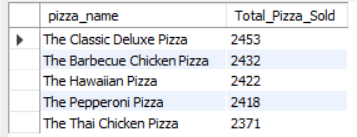
- Bottom 5 Pizzas by Quantity Sold: Identified the least popular pizzas.
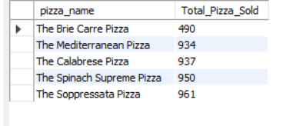
- Order-Based Analysis
- Top 5 Pizzas by Total Orders: Found pizzas appearing most frequently in orders.
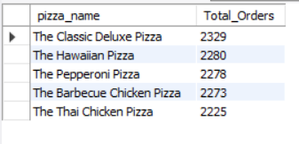
- Bottom 5 Pizzas by Total Orders: Identified pizzas with the lowest order frequency.
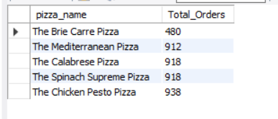

5. Dashboard in Power BI
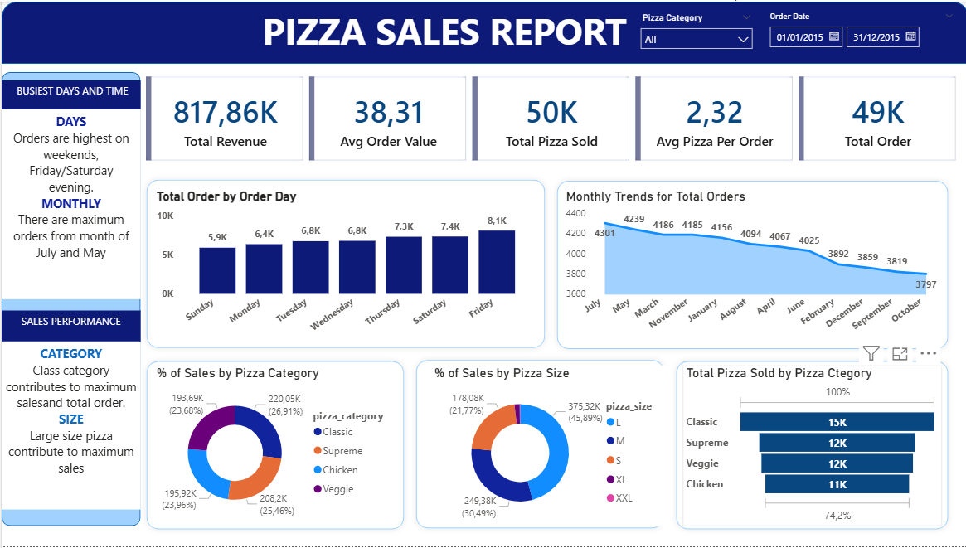
6. Business Recommendations
- Optimize Menu: Focus on best-selling pizzas and consider removing low performers
- Peak Hour Strategy: Increase staffing and promotions during high-demand hours
- Product Promotion: Highlight top-performing categories in marketing campaigns
- Pricing Strategy: Adjust pricing or bundle offers to increase average order value
- Sales Forecasting: Use trends to plan inventory and operations efficiently

